

Income and Population: Key Drivers for Targeted Expansion

Chenny Rose Castillo

The aim of this analysis is to understand how income levels and population significantly influence our expansion choices. These fundamental drivers will guide us in expanding and nurturing the startup company's growth.

# Data Analysis Overview

This project involves the analysis of data to support the expansion and growth of a startup company in the “Health Tracker Smart Watch” business. By leveraging various data analysis techniques and tools, the project aims to provide insights that will guide the selection of the most promising states for the company's expansion.

Type of Data Analyzed: The data analyzed in this project includes a combination of financial and demographic information. It includes financial metrics from competitor companies, such as gross profit and operating expenses, which are used to compute financial viability metrics. Additionally, demographic data related to income levels and population sizes of different states is utilized.

# Business Questions

**Which states are the most suitable for expansion based on State Income Analysis, Population and Profit Correlation, Healthcare Spending Analysis, and Operational Efficiency Analysis?**

**State Income Analysis:**

Q1: Which states are among the top 5 with the highest income per capita?

Q2: What is the average income for each state, and how do they rank based on their income?

**Population and Profit Correlation:**

Q3: Is there a correlation between the population of a state and its profit?

**Healthcare Spending Analysis:**

Q4: How is healthcare spending distributed across different states?

Q5: How does the average healthcare spending per person vary among different states?

Q6: Is there a relationship between healthcare spending per person and the income of a state?

**Operational Efficiency Analysis**

Q7: Which state exhibits the highest and lowest level of market competition based on the analysis of financial viability metrics, specifically focusing on Operating Profit Margin.

## Methodology for Analyzing Expansion Opportunities

#### Data Cleaning and Preparation:

* Removed District of Columbia as it's not a state but a federal district.
* Addressed null values and incomplete data as best as possible given limited resources.

#### Identifying Suitable States for Expansion:

* Utilized various tools and platforms for analysis: Postgres, Excel, Power BI, Python.
* Income Level Analysis, Correlation Analysis, Financial Viability Metrics, Health Spending and Income Analysis

#### Visualization, Conclusions, and Recommendations:

* Present findings from income analysis, population correlation, financial viability metrics, and healthcare

spending.

* Made recommendations based on the analysis, such as selecting states with high income per capita and potential correlation between population and profit.

## Assumptions and Limitations

#### Assumptions and Limitations

* For Financial Viability Metrics, the profit mentioned in the "Competitors" dataset is interpreted as “Gross

profit” the total revenue minus the cost of goods sold (COGS).

* For Financial Viability Metrics, since we only have operating expense and gross profit, we used “Operating Profit Margin”.

#### Challenges in the Analysis

* Scarcity of resources and the presence of null values or incomplete data.
* Due to the limited availability of domain experts for consultation, proactively made reasonable assumptions to address the gaps in information.

Postgres

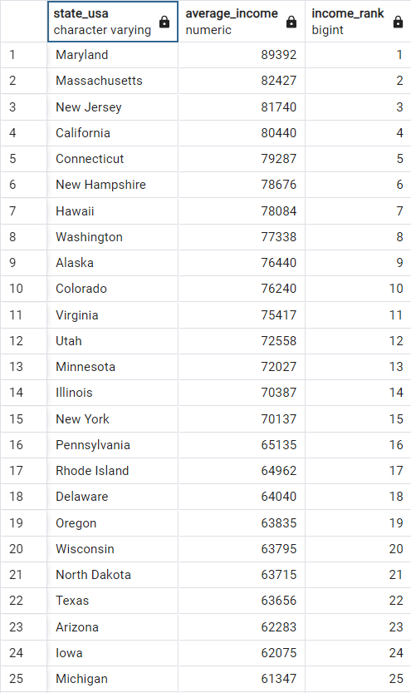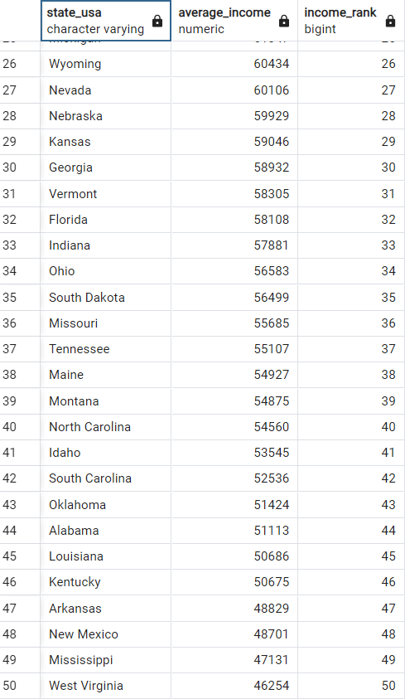**Top 5 States with the Highest Income per Capita Average Income for each State and Rank based on Average Income**

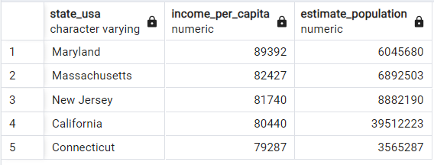

**Correlation between Population and Profit**



During the analysis, the top 5 states with the highest income per capita are **Maryland**, **Massachusetts**, **New Jersey**, **California**, and **Connecticut**. A correlation of -0.0447 indicates a **weak negative correlation** between population and profit. This implies that changes in population are not strongly linked to changes in profit.

# Excel

Correlation between Population and Profit

Pivot Table: Income Per Capita by State (Top 5 States Highlighted)

18000000

16000000

14000000

12000000

10000000

8000000

6000000

4000000

2000000

0



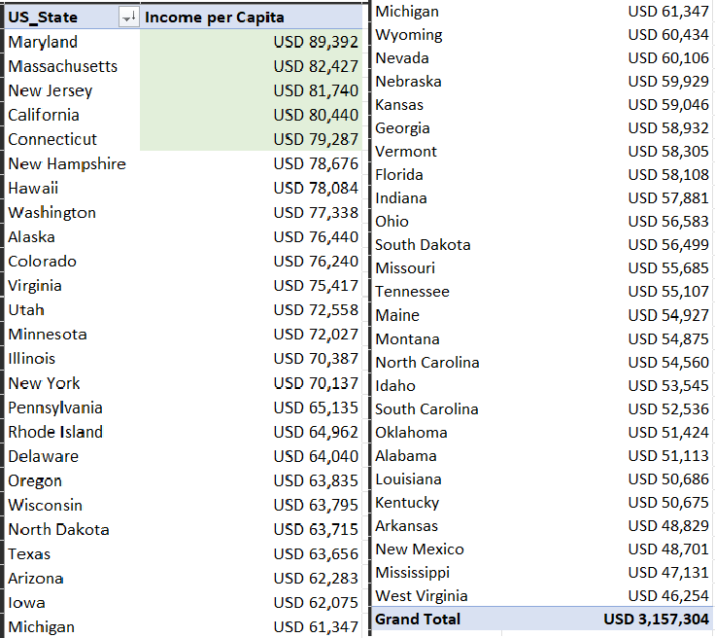0 10000000 20000000 30000000 40000000 50000000

The scatter plot suggests a **weak negative correlation**. Other factors and variables could be influencing the observed relationship. The Top 5 States with the highest Income Per Capita by State remain the same with the output in Postgres.

# Power BI

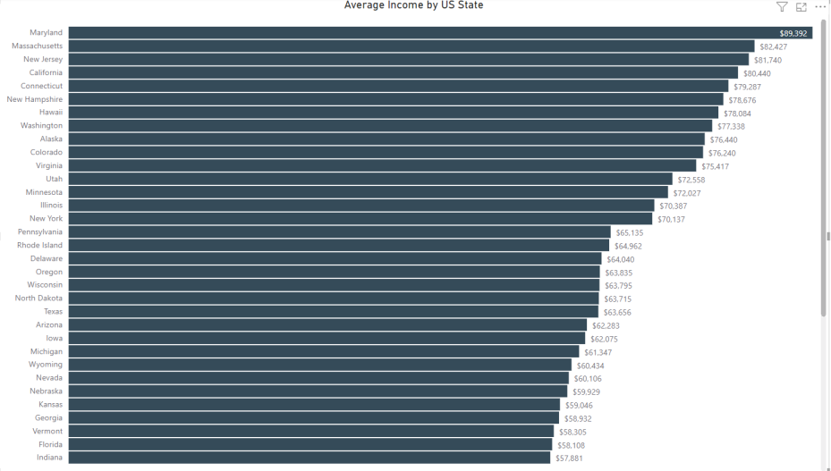

The upper-left box and lower right box correlation of 1 represents the correlation of population and profit with itself, which will always be 1.00 (perfect positive correlation) since a variable is perfectly correlated with itself.

The upper-right box and the lower-left box has a **correlation of -.04** which implies a **weak negative correlation** between population and profit.

Note that Correlation does not imply Causation and Correlation only captures

linear relationships.

As depicted in the charts on the right side, the top 5 states with the highest income per capita remain **Maryland, Massachusetts, New Jersey, California, and Connecticut**, in that respective order.

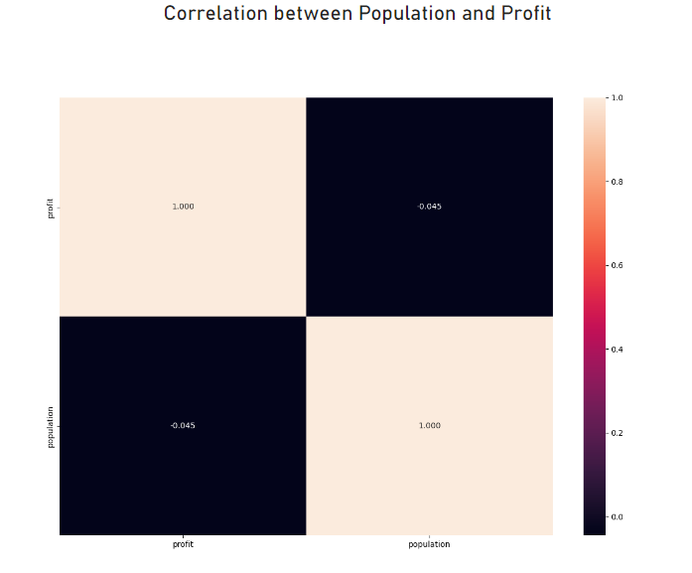

Python

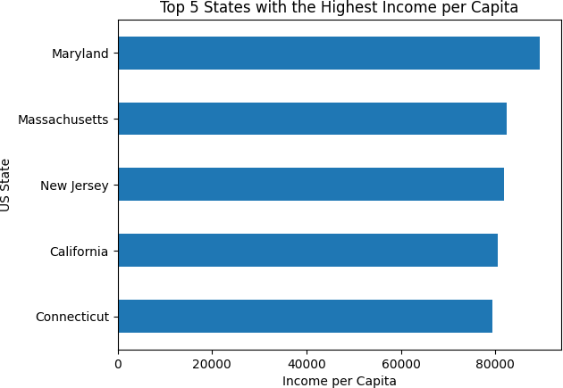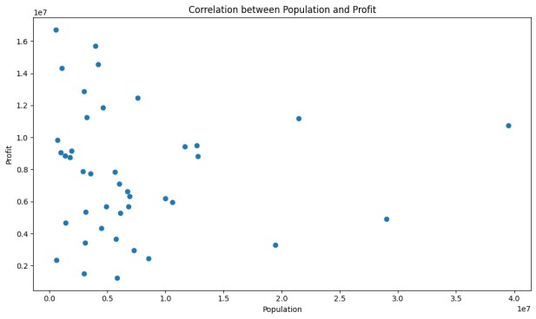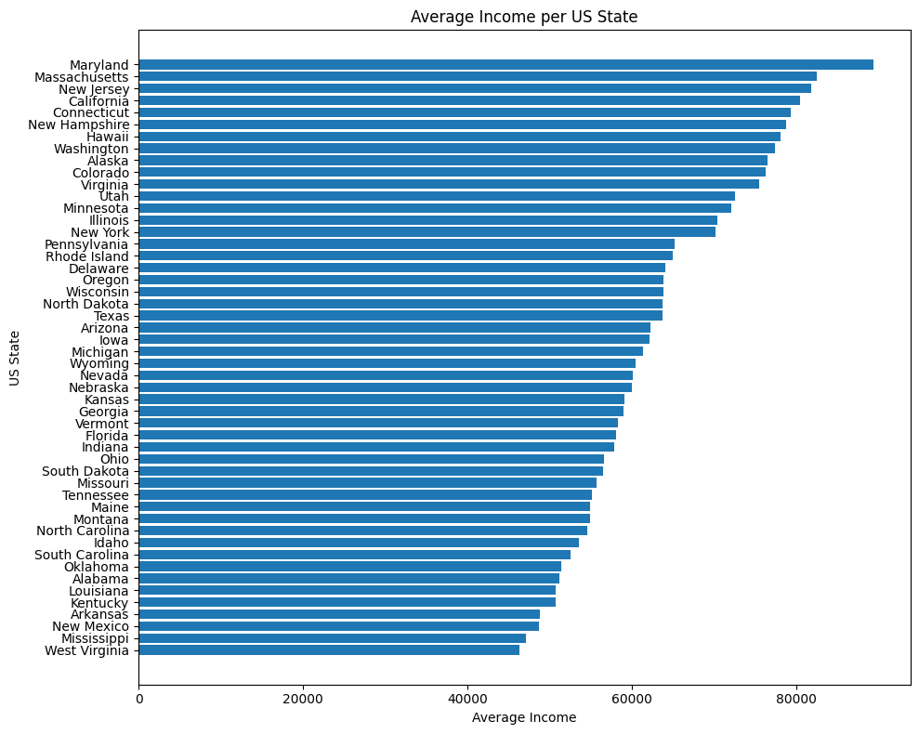

Consistent with our observations from Excel, Postgres, and Power BI, the top 5 states with the highest income per capita are **Maryland, Massachusetts, New Jersey, California, and Connecticut,** in that respective order.

Additionally, the correlation analysis indicates a **weak negative correlation**.

Healthcare Spending Analysis

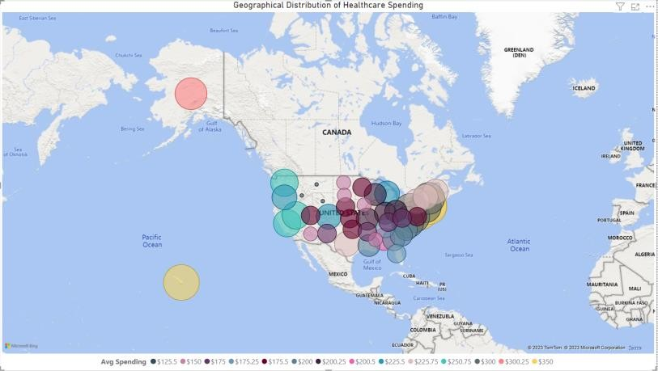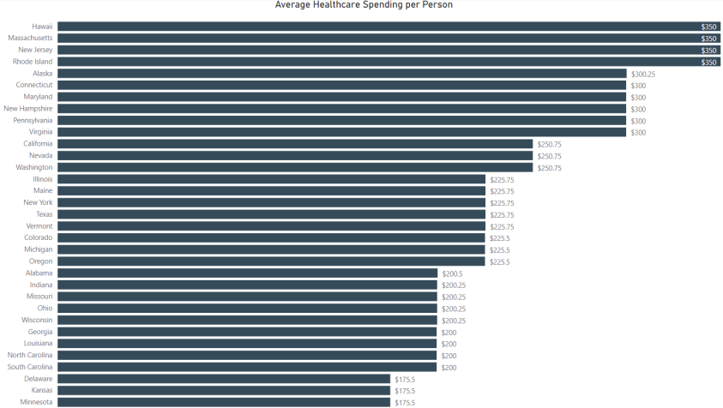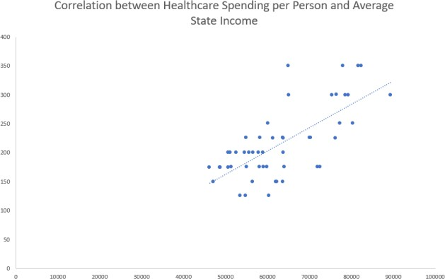

Top states with the highest average healthcare spending per person **are Hawaii, Massachusetts, New Jersey, Rhode Island, and Alaska**, in that respective order.

A Correlation **coefficient of 0.704** suggests a **moderately strong positive linear correlation** between the average income and average healthcare spending per person. This means that as the average income increases, the average healthcare spending per person tends to increase as well, and vice versa.

Financial Viability Metrics of Competitors: Operating Profit Margin

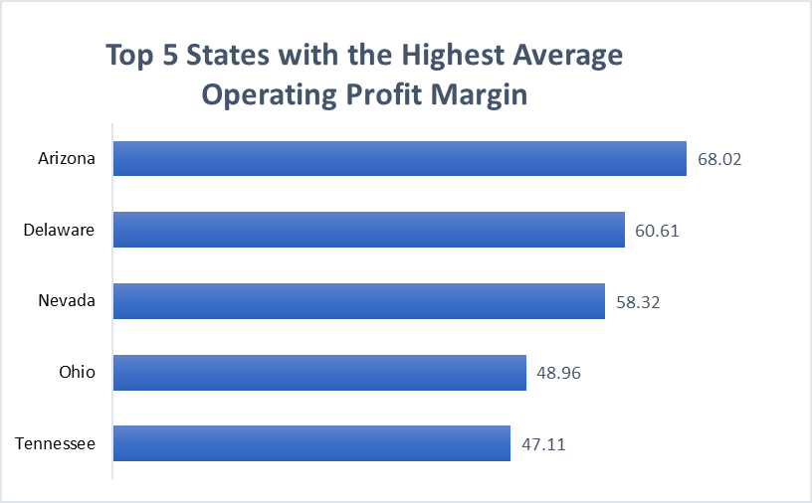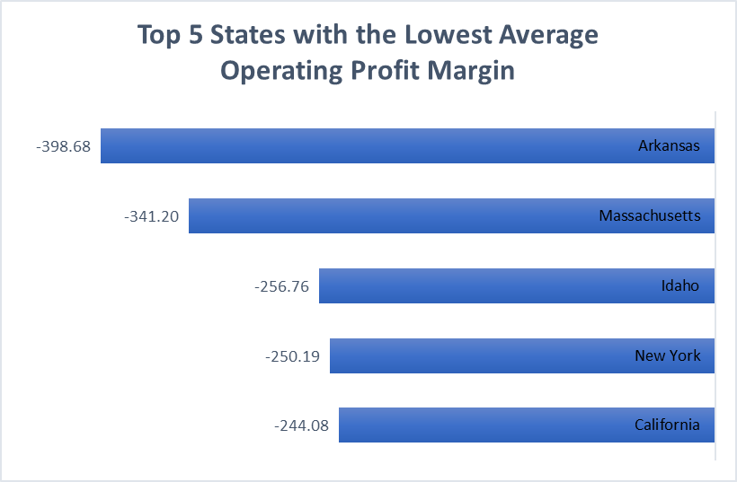

This metric represents the portion of gross profit that remains after subtracting operating expenses. It offers insights into how effectively the company is handling its operating costs.

Additionally, it helps identify the states with the **highest and**

**lowest competition levels**.

# Summary and Implications

### Summary of Findings and Insights

In this analysis, we discovered that the top 5 states with the highest income per capita are **Maryland, Massachusetts, New Jersey, California, and Connecticut**. We also determined that there's a **weak negative correlation** of -0.04 between population and profit. It's important to recognize that Correlation does not imply Causation, and Correlation specifically pertains to linear relationships. In cases where the association between two variables is nonlinear, the correlation coefficient may not effectively capture the true underlying relationship.

Additionally, we identified the top states with the highest average healthcare spending per person: **Hawaii, Massachusetts, New Jersey, Rhode Island, and Alaska**. The correlation coefficient of 0.704 indicates a **moderately strong positive linear correlation** between average income and healthcare spending per person. This suggests that higher average income is associated with higher healthcare spending per person. While a positive correlation suggests that there is a relationship between the two variables, it does not necessarily mean that changes in one variable are causing changes in the other variable. Other factors and variables could be influencing the observed relationship.

Lastly, we found that the top 5 states with the highest average operating profit margin are **Arizona, Delaware, Nevada, Ohio, and Tennessee**, in that order. On the other hand, the states with the lowest average operating profit margins are **Arkansas, Massachusetts, Idaho, New York, and California**, in that order.

# Summary and Implications

### Strategic Directives

After reviewing the analysis, it's advisable to consider expanding into **New Jersey**. This state stands out in the data with both high income per capita and average healthcare spending per person. This suggests that New Jersey residents might have the financial capacity to invest in our products.

If you're exploring another state, I would recommend **Massachusetts**. This state also stands out in the data with high income per capita and average healthcare spending per person. However, be aware that they have one of the lowest average operating profit margins. Therefore, before recommending an expansion there, it's important to investigate other factors such as **market demand**, **consumer behavior**, and **economic trends**.

Lastly, due to our limited data, to further enhance our expansion decision, I would suggest that the company assess the state’s **talent pool**. Evaluate the availability of skilled talent in the technology and healthcare sectors. Additionally, explore **partnerships and collaborations** by researching potential partnerships with local businesses, healthcare providers, or technology hubs that can support your expansion efforts.

END.